EXP-15 GFDM vs OFDMA Comparison using MATLAB

AIM: To compare the time-domain waveform characteristics of OFDMA and GFDM modulation schemes by generating and visualizing their signals using MATLAB.

APPARATUS REQUIRED
1.MATLAB / Octave software (with Signal Processing and Plotting tools)
2.Computer or Laptop with minimum 4 GB RAM
3.Simulation script for Array Factor analysis
4.Graph plotting utilities (built into MATLAB)
5.Documentation tools (MS Word for tabulation of results and screenshots

THEORY:

OFDMA (Orthogonal Frequency Division Multiple Access)

Uses orthogonal subcarriers.

Each subcarrier carries one symbol without pulse shaping.

Simple implementation but produces high out-of-band emissions (OOBE).

Suitable for LTE and 5G sub-6 GHz.

GFDM (Generalized Frequency Division Multiplexing)

Multi-carrier scheme with subcarriers and subsymbols arranged in a block.

Uses pulse shaping (e.g., raised cosine) to reduce interference.

Offers low OOBE and flexibility but is more complex.

Considered for 5G waveforms.

Key difference:

OFDMA → purely orthogonal, rectangular pulses.

GFDM → non-orthogonal, pulse-shaped symbols.

PROCEDURE
- Define number of subcarriers, subsymbols, modulation order, and samples per symbol.
- Generate random QPSK symbols for each subcarrier and subsymbol.
- OFDMA generation:
- Upsample each symbol.
- Modulate each onto a cosine at the subcarrier index.
- Add signals across subcarriers.
- GFDM generation:
- Upsample data.
- Apply raised cosine pulse shaping.
- Modulate onto subcarriers.
- Plot:
- QPSK symbol values
- OFDMA waveform
- GFDM waveform
CODE:
clear; clc; close all;

%% PARAMETERS
N_subcarriers = 8; % Number of subcarriers
N_subsymbols = 4; % Number of subsymbols per subcarrier
M = 4; % QPSK modulation
sps = 8; % Samples per symbol for pulse shaping

slice_names = {'OFDMA','GFDM'}; % For legend

%% GENERATE RANDOM DATA
data = randi([0 M-1], N_subcarriers, N_subsymbols);

% QPSK mapping: 0->1+1j, 1->1-1j, 2->-1+1j, 3->-1-1j
data_mod = exp(1j*2*pi*data/M);

%% -------------------- OFDMA WAVEFORM --------------------
ofdm_signal = zeros(1, N_subcarriers*N_subsymbols*sps);
for k = 1:N_subcarriers
sym_up = upsample(real(data_mod(k,:)), sps); % upsample for time resolution
t_index = (1:length(sym_up)) + (k-1)*length(sym_up);
ofdm_signal(t_index) = ofdm_signal(t_index) + sym_up .* cos(2*pi*(k-1)/N_subcarriers*(0:length(sym_up)-1));
end

%% -------------------- GFDM WAVEFORM --------------------
beta = 0.25; % Roll-off factor
span = 4; % Filter span in symbols
rc_filter = rcosdesign(beta, span, sps); % Raised Cosine filter

gfdm_signal = zeros(1, N_subcarriers*N_subsymbols*sps);
for k = 1:N_subcarriers
sym_up = upsample(real(data_mod(k,:)), sps); % upsample
filt_sym = conv(sym_up, rc_filter, 'same'); % apply pulse shaping
t_index = (1:length(filt_sym)) + (k-1)*length(filt_sym);
gfdm_signal(t_index) = gfdm_signal(t_index) + filt_sym .* cos(2*pi*(k-1)/N_subcarriers*(0:length(filt_sym)-1));
end

%% -------------------- PLOTS --------------------
figure;

% a. Random QPSK data
subplot(3,1,1);
stem(real(data_mod(:)),'filled');
title('Random QPSK Data for Subcarriers and Subsymbols');
xlabel('Symbol Index'); ylabel('Amplitude'); grid on;

% b. OFDMA waveform
subplot(3,1,2);
plot(ofdm_signal,'LineWidth',1.5);
title('OFDMA Waveform (Time Domain)');
xlabel('Sample Index'); ylabel('Amplitude'); grid on;

% c. GFDM waveform
subplot(3,1,3);
plot(gfdm_signal,'LineWidth',1.5);
title('GFDM Waveform with Pulse Shaping (Time Domain)');
xlabel('Sample Index'); ylabel('Amplitude'); grid on;

OUTPUTS:
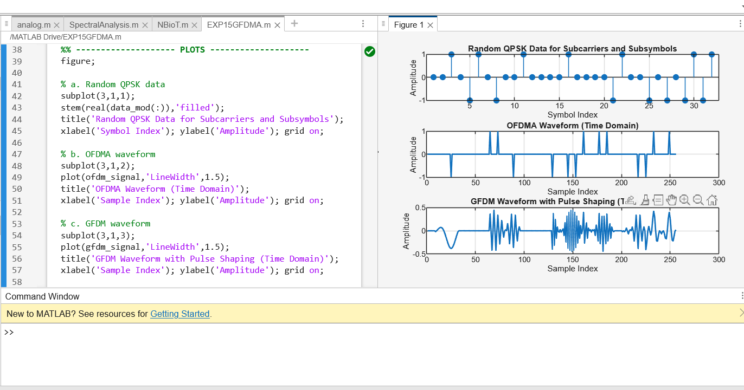

RESULTS:
The MATLAB comparison confirms that OFDMA provides a simple, orthogonal signal structure, while GFDM offers improved spectral characteristics through pulse shaping. Although GFDM yields smoother time-domain signals with lower out-of-band emissions, it introduces implementation complexity. Therefore, OFDMA is preferred for legacy LTE systems, while GFDM provides flexibility for advanced 5G physical layer designs.

